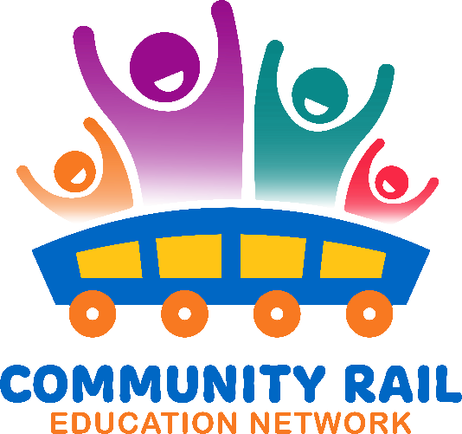
Thursday18th April 2024

Agenda
10:00-10:05 – Welcome
Bev – Herewood line
Catherine – CRL Education
David – Station adopter – Kettering
Dawn – Barton and Cleethorpes CRP
Kyle – Queensland Rail
Felicity – Bishop Line
Ian – CRN – support and development officer
Imogen – Platform
Jess – Rail education officer – Bishop Line
Julia – Heart of England
Kaye – EMR
Nancy – EMR
Nicola – Porter Brook Leasing
Rachel – Avanti
Robert – Friends of Ingatestone Station
Sarah W – Penistone Line
Sophie – Volker rail
Stephen – Marston Vale CRP
Shuna – Skanska
Tracy - Scotrail

10:05 – 10:15 – Updates – including Platforms for Change, Backtrack, Arlo’s Adventures
Platforms for change – 80 Scout groups have a host station – CRPs, station adopters, Friends of groups, TOCs, Network Rail managed stations. Still 60 Scout groups who haven’t got a station. Hopefully a media launch at the end of June – watch out for an email.
Backtrack – Group have had a think about the way forward – Move the times of the competition to within a school year. Launch in September this year. LearnLive are going to support next year to get video entries and with a broadcast with the winners for June 2025. Any entries for this year we will judge in June so please let us have them. Current form is still going to be usable so don’t get rid of them.
Arlo – Arlo 2 is in the process of being made – Careers focus with a summer launch. Bessie will share to ensure a good spread of careers in the book. Also hopefully an Arlo for Railway 200

10:15 – 10:20 – Potential link up with Trainline and “I came by train” campaign. For those not familiar with this you can have a look here: I Came By Train | Sustainable Travel | Green Low Carbon Trains (thetrainline.com)
Potentially something that can happen between CRN and Trainline. They currently sponsor Scenic Rail. I came by train to promote a modal shift and want to develop resources for young people (esp. secondary and college) to use the train. CRN (Karen) hopefully to develop resources to support young people with train use. I came by train launch was well attended by railway industry and the focus has an aim for model shift, sustainability, rather than using the app.
Possibility of bringing everything together that TOCs and CRPs have already made.

Julia – resources for secondary would be great.
Imogen - Yes - sustainability themed resources for KS3+ would be great
Rachel – Avanti – Sustainability team have some secondary resources and can link up their team with whoever is developing the resources.
Jess - Having resources that will engage secondary will be great
Sarah - PLP would promote an app in colleges and youth groups. Hoping to have a youth group as station adopters soon!
Stephen - We would use this - great idea!
Robert - GA used to have a Secondary link taking pupils here around Stratford on train simulators etc but I do not think these have been organised since the pandemic. We have some 600+ pupils coming in by train each day, with a very wide ethnic and nationality range. (Some 75 languages at our school).

Jess - I'd be interested in being in a development group if that's a possibility

Sarah W - The group I'm speaking about are Young Commissioners between 11 - 22 and stay with the youth group for years, they work with the local civic centre too, who could support a development project, they would love it!

Bev – Possibly put something on TES online to support teachers

Tracy - when I visit secondary schools its generally because of reports of ASB or careers conversations. When I am there I deliver a presentation that covers ASB/RAIL SAFETY/CAREERS – So something to add on the end of this.

10:20 –10:30 – Rail Safety Week Updates
Wk. com 24th June led by Rail Forum.
Slide show available about Rail Safety
Let Jemma know any activities
If you want to go to the launch on the 24th June let Karen know and she will send you the link
29th June – Possibly a big Arlo hand out across the country. If a week day works better then that’s fine. Let Karen know if you want to hand some to hand out or if you want a station to link up with. Rachel Jones at Avanti would like some Arlo books.
Robert - I will ask Essex & South Suffolk for Arlo copies here

Julia - I could do some on the 29th at Leamington if I could get some more copies please
Beverley - I would like to participate on that Saturday at Peterborough but will need some books.
Julia - I may have a new officer in post by then too so we may be able to do another station too

10:30- 10:40 – Updates from Queensland Rail
Projects – Deliver Rail Safety Education sessions, Rail safety orientation days, etiquette on trains
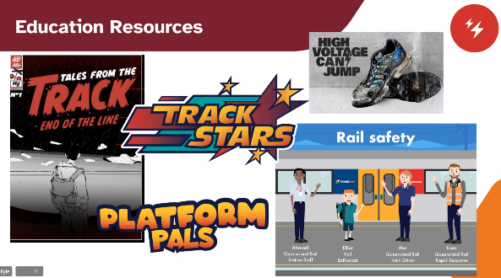
Kindergarten to older age
Now beginning to work with seniors
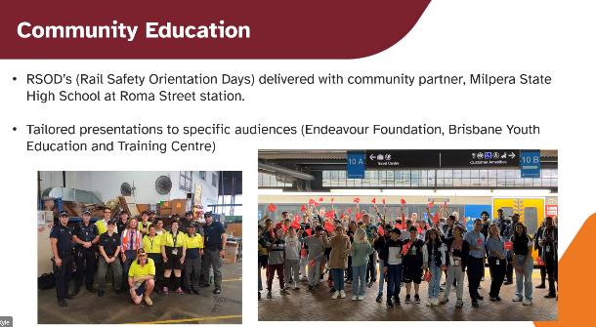
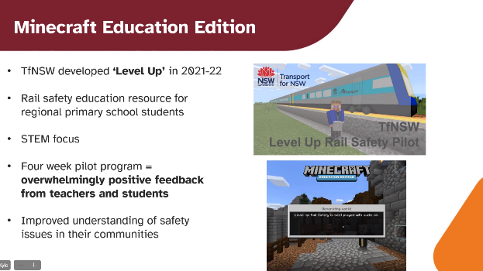
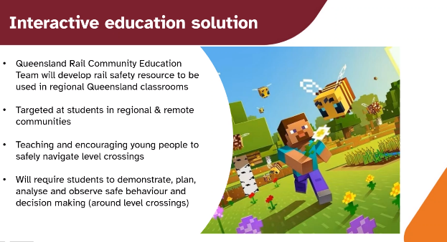
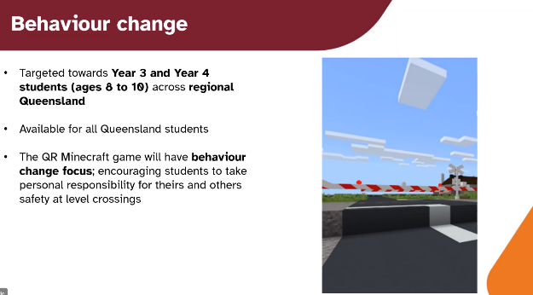

Dawn - Kyle, I'd be very interested in knowing more about the Minecraft work

Nancy - Love this Minecraft idea, agreed very interesting stuff & etiquette is a great idea. thanks for your presentation Kyle

Sarah W - How is the Minecraft development funded? – Government, Transport for ???, Queensland Rail

Tracy - does Queensland Rail work with Tracksafe foundation? Kyle - They do. Share resources. Work with the ambassador. Tracksafe is Australia wide supporting safety across the railway industry, lining all of the states together.

We will share this with each other over future meetings
https://tracksafefoundation.com.au/
VR headsets - Network Rail simulations, Northern’s accessible simulation.
Railway Reality Check - https://www.youtube.com/watch?v=ZekySm3EMwM

Karen shared Rail Safety Week slides

