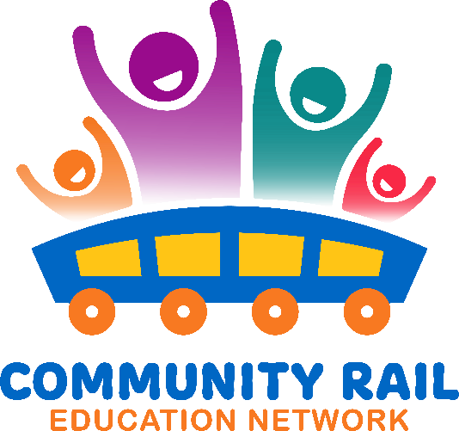

Thursday 27th February

10-10:10 Welcome and intros

Attendees:

|  |
| --- |
| Karen Bennett - CRN |
| Thalia Woodgate – East Suffolk |
| Sarah Muir -Mid Cheshire |
| Simone Cuozzo – Italian Rail |
| Sue - MICheldever Station |
| Christy Argyroudi (GBRTT) |
| David Savage -CRN |
| Rhona Smith - Elizabeth Line |
| Sarah Wells – Penistone line CRP |
| Felicity Machnicki -Bishopline |
| Sam Agnew - CRN |
| Tiffany Allen - CRN |
| Jess Young Bishopline |
| Steve Booth Purbeck |
| Jenni Jones CRN |
| Rick Craig North Notts and Lincs |
| Fiona Forsythe Tyne Valley |
| read.ai meeting notes |
| Catherine Kingdom - CRN |
| Sandy Mahon SE CRP |
| Sarah Chilton- CRN |
| Daniel Ball - Education Officer Watercress Line heritage railway |
| Nicola Dooris – Network Rail |
| Tracy Stevenson Scotrail |
| Liu, Helen – South Eastern |
| Catherine Croney High Peak and Hope Valley |
| Dawn Branton Barton to Cleethorpes |
| Alex Sperr (External) Railway Children |
| Helen Wright (Place) High Peak and Hope Valley |
| Stephen Sleight – Marston Vale |
| Karen Caruso - Churchill |
| Robert Fletcher-Friends of Ingatestone Station |
| Hannah Bromage Grand Central |
| Nancy Roberts – East Midlands |
| Joe Spencer -Railway children |
| Ian Davis - CRN |
| jill tiernan Settle Carlisle |
| Sheila Davidson -Friends of Hindley |

10:10 – 10:20 – Updates – KB – 200 stories of Railway pride. Please encourage contacts to take part and share with groups. More info here: [200 Stories of Railway Pride - TrainEd](https://trained.website/project/200-stories-of-railway-pride/)

10:20 – 10:40 – Christy Argyroudi from Railway 200 about the Exhibition train. Including: first route announcement, how to get involved, volunteering

Christy’s email: [christy.argyroudi@gbrtt.co.uk](mailto:christy.argyroudi@gbrtt.co.uk)

Process for getting involved with groups – email Christy who will put you in touch with local steering group.

Please alert Railway 200 to any activities you have planned so they can put on the map and share on social channels: <https://railway200.co.uk/search-for-activities-and-events/>

Details of the shop: <https://shop.sciencemuseum.org.uk/collections/railway-200?srsltid=AfmBOoqMuPpXN4j8uo7urv9qZlIzp-EagK1zoQPVN0Ao1LRdW68ig1Dp>

10:40 – 10:55 – Discussion from group on Railway 200 train/and other projects

Catherine Kingdom – Girl Guides Badge launch 29.3.25 please contact her for more details [Catherine.kingdom@communityraillancashire.co.uk](mailto:Catherine.kingdom@communityraillancashire.co.uk)

Daniel Ball email for Watercress Line activities: [education@watercressline.co.uk](mailto:education@watercressline.co.uk)

Dave Savage – Theatre production details: <https://garetheatre.com/current-productions-2/>

Race the train details <https://www.madbullevents.com/events-1/race-the-train-2025-bury-to-rawtenstall-as-seen-on-yesterday-tv-episode-5>

10:55 – 11:00 – AOB

Next meeting Weds 19th March at 10 – Network Rail and Emily the Engineer campaign