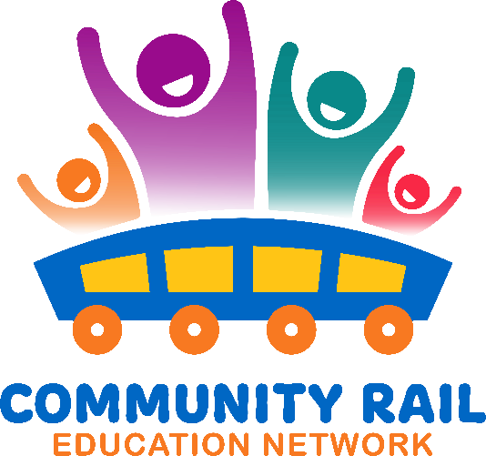

Wednesday 19th March

Attendance:

|  |
| --- |
| Karen Bennett - CRN |
| Ben Walsh - Independent |
| Hayley Weiss - NR |
| Thalia Woodgate -East Suffolk |
| Sarah Grove (External) – Meldreth Shepreth and Foxton |
| Bill Freeman - CRN |
|  |
| Laura Turnbull - MerseyRail |
| Jess Young- Bishopline |
| Rebecca Dunroe – White Cliffs |
| Butterfield, Peter- CR Cumbria |
| Steve Booth -Purbeck |
| Alex Sperr – Railway Children |
| Chris Mclaughlin - NR |
| Baggaley, Shuna- Skanska |
| Salrita Sheen-Suresh C2C |
| Claire Cooper C2C |
| Jayne Sumner – Essex and South Suffolk |
| Rachel Osborne -Yorkshire Coast |
| Karen Caruso= Churchill |
| Amit Kotecha – Network Rail |
| Andy Buckley- Beds and Herts |
| David Savage CRLancs |
| Ian Davis - CRN |
| Sarah Wells- Penistone Line |
| Stephen Lethorn – Southern/GTR |

10-10:10 Welcome and intros

10:10 – 10:25 – Updates – including Railway 200 and Rail Safety Week

R200 - See attached list of contact details for stations on the first part of the Exhibition course.

RSW – Will be taking place W/C 16th June. 10th year this year. For more info:

[Rail Safety Week](https://www.railsafetyweek.org/)

The conference will take place at Rail Live on 18th/19th June. To sign up to attend the event for free: [Rail Live 2025 | June 18–19, 2025](https://raillive.org.uk/)

Next meeting, we will spend some time discussing ideas for activities for this

10:25 – 10:45 – Network Rail and the Emily the Engineer programme

Amit Kotecha – Network Rail [Amit.Kotecha@networkrail.co.uk](mailto:Amit.Kotecha@networkrail.co.uk)

List of stations and itinerary attached. Please reach out if you’d like to join event or host one at a station near you. There are copies of the book you can order for other events too.

See PDF here: [Emily-the-Engineer-FINAL-copy.pdf](https://www.networkrail.co.uk/wp-content/uploads/2024/07/Emily-the-Engineer-FINAL-copy.pdf)

10:45 – 10:55 – Discussion from group on the programme

10:55 – 11:00 – AOB

Dave Savage – Community Rail Lancashire - [Dave.savage@communityraillancashire.co.uk](mailto:Dave.savage@communityraillancashire.co.uk)

Following on from successful Feel Good Field Trip programme – now doing Feel Good Futures with Avanti West Coast. Dave is looking for places he can visit along the WCML eg train care centres, heritage centres etc he can take groups with a careers focus. Dave also looking for groups to take, so if you’re based along this route and have contacts please do get in touch with him.

Karen Bennett – with her CRL hat on! 200 stories of Railway Pride! Only 12 days until submission day! Please continue to share the project with your contacts and consider writing an entry yourself. The project is open to LGBTQ+ community and allies too. Many heterosexual colleagues have entered stories about projects they’ve worked on like Trainbows or Pride events. For more info: [200 Stories of Railway Pride - TrainEd](https://trained.website/project/200-stories-of-railway-pride/)