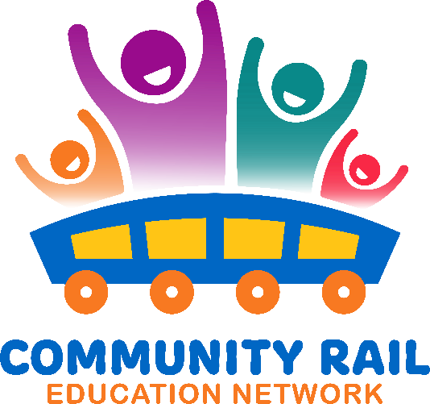

Wednesday 28th May  
In attendance:

|  |
| --- |
| Karen Bennett |
| Marc Wade (External) |
| Ben Walsh |
| Caroline Lee |
| Claire Cooper (External) |
| Birch, Warren |
| Shahiesta (Unverified) |
| Dawn Branton (External) |
| Sarah Grove (External) |
| David Savage |
| Liu, Helen |
| Alex Bray |

10-10:10 Welcome and intros

10:10 – 10:15 – Updates

Backtrack Competition film is ready for Rail Safety Week – will go out on social channels throughout the week – it would be great if members could share this on their own channels

10:15-10:40 – Shahiesta Raja – Community Rail Lancashire Working with Diverse Groups

See attached slides

Shahiesta’s email is: Shahiesta.raja@communityraillancashire.co.uk

Including projects involving Stations of Welcome adoption group, Ramadan at stations, visits to the mosque, working with refugee groups.

10:40 – 10:55 – Discussion – other similar projects, how you could do something similar at your CRP, Q and A to Shahiesta

10:55– 11:00 –AOB