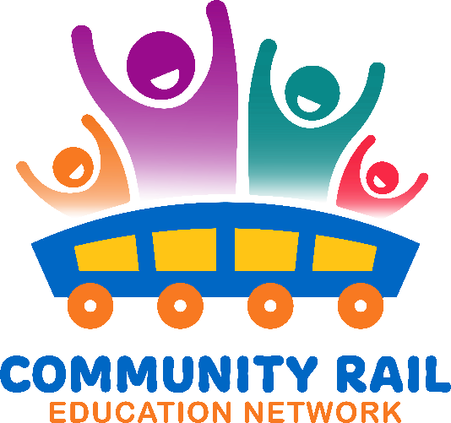
Wednesday 16th July
Attendance
Karen Bennett
Joanne Wormald (External)
Caroline Lee
Rebecca Dunroe (External)
Chris Hughes (External)
McGough, Dawn M
Catie Lake (Unverified)
Fiona Forsythe
Deborah Rodenby
Kate Ribchester (External)
John (he/Him) _- MESMAC (Unverified)
David Savage
Tom Blow (External)
Anna Hughes (External)
Jayne Sumner - Rail Engagement Manager
Liu, Helen
Andy Buckley (External)
Thalia Woodgate
Woods, George (SMO UKI RC-GB EHS)

11-11:05 Welcome and intros
11:05 – 11:15 Karen Bennett 200 stories of railway pride – see attached slides
11:15– 11:25 – Fiona Forsythe –from Tyne Valley working with Queer Cumbria
11:25 – 11:35 – Kate Ribchester from Brunswick Centre – see attached slides
11:35 – 11:45 – John Dugdale from MESMAC
11:45 – 11:55- Chris Hughes – from LonGBoaT (Wakefield Kirkgate Adoption Group)
11:55 – 12:05 – Joanne Wormald – from George House Trust
12:05 – 12:15 – Q and A

