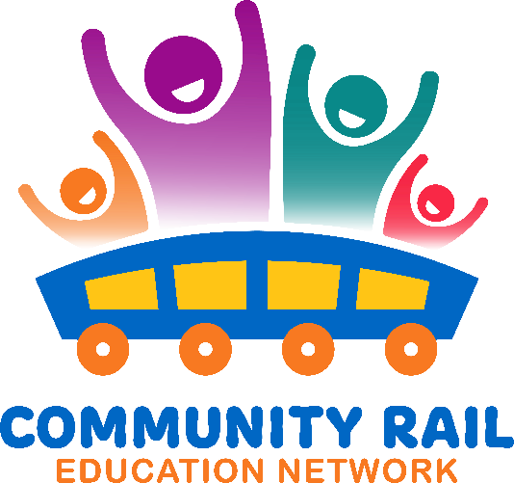

Wednesday 20th August

10-11

In attendance:

|  |
| --- |
| Karen Bennett - CRN |
| Deborah Rodenby - Nexus |
| Thalia Woodgate – East Suffolk CRP |
| Ben Walsh – Hereward CRP |
| Hayley Weiss – Network Rail |
| Rachel Osborne (External) – Yorkshire Coast |
| Mike Lamport (Unverified) – Railway 200 |
| David Savage - CRL |
| Gary Outram – Kent CRP |
| Stephen Sleight (External) – Marston Vale |
|  |
| Andrew Watkins (External) - TPE |
|  |
| Alex Peel - CRN |
| Steve Booth (External) - Purbeck |
| Becca Hill (External) - NRM |
| Sarah Grove (External) – Cam valley CRP |
| daniel ball – Watercress Line |
| Harry Burr - Chiltern |

10-10:10 Welcome and intros

10:10 – 10:15 – Intro from Karen about the Inspiration Train

* See attached slides

10:15– 10:25 – Dave Savage – CRL

* See attached slides

10:25– 10:35 – Gary Outram – Kent CRP

For more info: [Inspiration – The Railway 200 Exhibition Train, Margate, Sunday 20th – Monday 21st July](https://kentcrp.org/inspiration-the-railway-200-exhibition-train-margate-sunday-20th-monday-21st-july/)

10:35 – 10:45 – Harry Burr – Chiltern Railways

See attached slides

10:45 – 10:55- Discussion

10:55 – 11:00 – AOB