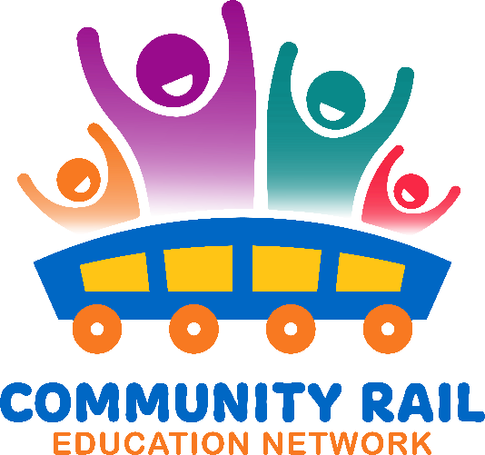
Wednesday 17th September
10-11
In attendance:
Name
Karen Bennett - CRN
Madeleine Mills South East Communities RP
Sarah Wells - Penistone Line
Kaye Robinson - EMR
Ben Walsh- Hereward CRP
Amy Powell - NR
Samantha - Heart of Wales Line
David Savage - CRL
Florence Pennant - Platform
Butterfield, Peter – CR Cumbria
Ian Davis- CRN

10-10:10 Welcome and intros
10:10 – 10:15 – Updates
10:15– 10:30 – Maddy Mills – Discussing how Southeast Communities CRP achieved the Learning Outside the Classroom Quality Badge
See attached slides
10:30 – 10:35 – Q and A to Maddy
10:35 – 10:55 – PSHE Updated curriculum – rail safety features! – Discussion
New curriculum attached
10:55 – 11:00 – AOB

