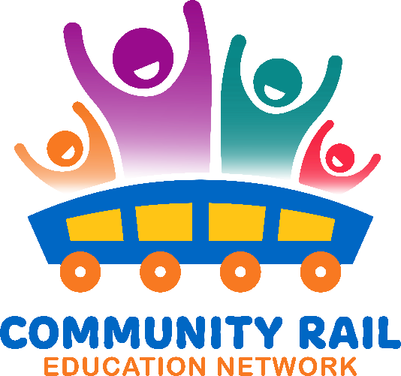
Wednesday 19th November
10-11
In attendance:
Karen Bennett
Kelly Pugh
Joanne Wormald (External)
Sophie Lounds (External)
Nia Hyett-Allen
Tom Blow (External)
Birch, Warren
Charlene Arrondeau
read.ai meeting notes (Unverified)
Robert Fletcher
Fiona Forsythe
Dawn Branton (External)
Uzma Ahmad (External)
Rebecca Catterall (External)
Kaye Robinson
Amy Bishop-Powell (she/her)
Baggaley, Shuna (External)
Lucy Smith (External)
Andy Buckley (External)
Cate Findlay
David Savage
Liu, Helen

10-10:10 Welcome and intros
10:10 – 10:15 – Updates
10:15– 10:40 – Sophie Lounds – A presentation on Platform Rail with time for Q and A
10:40 – 10:55 – Inspiration Train – dates for the rest of the year and how to get involved
10:55 – 11:00 – AOB

