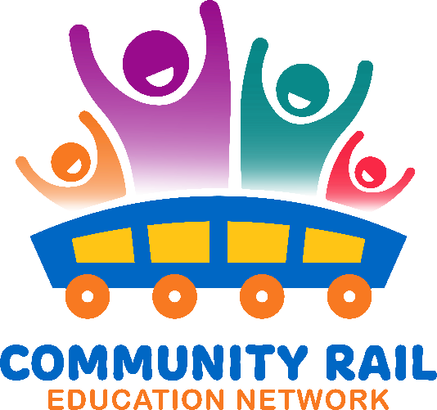
Wednesday 17th December
10-11
In attendance:

Karen Bennett
Fiona Forsythe
Nia Hyett-Allen (External)
Sophie Pearson
Felicity Machnicki (External)
Cate Findlay
Tom Blow (External)
Jess Young (DBC Highways & Capital Projects) (External)
Liu, Helen
Baggaley, Shuna (External)
Kimberley Sweet-Roberts
Tracy Stevenson (External)
David Savage

10-10:10 Welcome and intros
10:10 – 10:15 – Updates
10:15– 10:30 – Review of the Education Network in 2025 – see slides
10:30 – 10:55 – What shall we put on the agenda for 2026? – Discussion
Ideas include:
*Active Travel session – link with Gary’s network
* Sustainability
*Duke of Edinburgh Session
*permissions at stations/acquiring land
*event trains
*Using AI
* Girl Guiding
* External impact of school engagement
*work experience/apprenticeships/early careers with wider industry

10:55 – 11:00 – AOB

