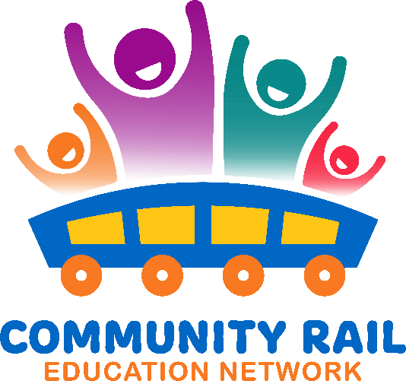
Wednesday 15th April
10-11
In attendance:
Karen Bennett
Jane Stewart - Community Rail Partnership Officer
Uzma Ahmad (External)
Rachel Osborne (External)
Jess Young (DBC Highways & Capital Projects) (External)
Alison Barker
read.ai meeting notes (Unverified)
David Savage
Chris Mclaughlin
Fireflies.ai Notetaker Charlen (Unverified)
Sarah Grove (External)
Rebecca Catterall (External)
Liu, Helen
Dylan Jones | Rail Forum (External)
Baggaley, Shuna (External)
Alex Bray
Sophia (Unverified)
Joe Spencer (External)
Sophie Lounds (External)
King, Chris (MS)
Butterfield, Peter
Tracy Stevenson (External)
Sophie Pearson
Sarah Davison (External)

10-10:10 – Introductions and welcomes
10:10 – Rail Safety Week - information and ideas
10:25 – Community Rail Week – information and ideas
10:40 – Group Discussion

