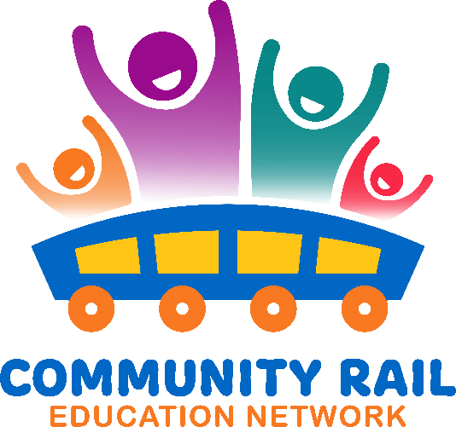
Wednesday 17th June
10-11
In attendance:
Karen Bennett
Jane Stewart - Community Rail Partnership Officer
Melissa Dalton (External)
Gemma Howe
Victoria Clent
Birch, Warren
Michael Thomas
Butterfield, Peter
Philip Merchant (External)
Joe Spencer (External)
Dawn Branton (External)
Evangeline Quek (External)
Liu, Helen
Ben Walsh
Catherine Kingdom (Unverified)

10 – Introductions and welcomes
10:10 – Introduction to the session – How the curriculum is changing in September
10:15 – Network Rail – Showcase of updated Switched On Resources
10:30 – Q and A
10:40 – Discussion – how can you use the new resources in your practice?
10:55-11 - AOB

